MICROSOFT POWER BI

# pROJECT:US CANDY DISTRIBUTION DAShBOARD

ABOUT DATA:

Sales and geospatial factory to customer shipment data for a US national candy distributor, including information around customer & factory locations, sales orders & goals, and product details.

**Of Fields:** 39

**Of Records:** 10,194

**Date Added:** 09/10/2024

**Dataset Link:** **https://mavenanalytics.io/data-playground**

## POwer bi: preprocessing [transformations]

* Data load to the power bi from the local disk
* STEP1: Changed first row as column for all the tables
* STEP2: Removed the row id in the sales table
* STEP3: Checked all the errors and empty in all the table and replaced
* STEP4: Removed one column, which totally empty in table of uszips
* STEP5: Make data types of all the columns in all the tables, Correctly
* STEP6: Corrected the number, which are currency
* STEP7: Created a duplicate table of sales to extract the year of ordered and shipment year

## POwer bi: REALTIONSHIPS [model view]

* Power bi automatically detected the relationships among all the tables
* One table **unzips** was didn’t connected, I make the relation with the **many to many** way using same column **city** in both tables of sales and unzips
* By that all the tables are connected in model view
* That relation make more comfortable to use the data of country, city, state, zip code and parameters in the table of unzips for analysis

### Model View of Relationships:

## Power bi: Dax Measures and conditional statements

* **Sum**: Calculates the total of a column or set of values.
* **Average**: Computes the mean of a column or set of values.
* **All** **Except**: Returns all values in a table or column, excluding specified filters.
* **SumX**: Calculates the sum over an expression evaluated for each row in a table.
* **RankX**: Ranks items within a table based on a specified expression.
* **Filters**: Defines or applies conditions to data to limit results shown.
* **Calculate**: Changes the context of a calculation by applying filters.
* **AverageX**: Computes the average over an expression evaluated for each row in a table.
* **Conditional Statement**: For Status of Gross Profit to know that is high (Greater than or equal to 65) or mid (Greater than or equal to 40) or low (Less than 40)

## Report 1: candy region analysis

### Key Components

1. **Filters (Left Panel)**:
   * **Year**, **Region**, and **Factory** dropdowns allow users to filter data displayed in the charts. Selecting different values will dynamically update all visuals on the dashboard based on the chosen criteria.
2. **Top Bar Segmentation Buttons**:
   * Buttons like "Chocolate," "High GP," and "Lot's O' Nuts" likely represent product categories or profitability filters. They allow users to focus on specific types of products or profitability levels.
3. **Main Bar & Line Chart (Centre)**:
   * **Sum of Sales** (blue bars) and **Sum of Gross Profit** (yellow line) are displayed by **Product Name**. This chart shows each product's sales volume alongside its profitability, helping to identify the best-performing products in terms of both revenue and profit.
4. **Radar Chart (Right)**:
   * This radar chart compares **Sum of Sales**, **Sum of Gross Profit**, and **Sum of Target** across four regions: **Pacific**, **Gulf**, **Atlantic**, and **Interior**. It helps to assess whether sales and profit targets are being met across different regions.
5. **Sales by Region (Bottom Left)**:
   * A horizontal bar chart showing the **Sum of Sales by Region**. It highlights total sales for each region, allowing users to see which region has the highest sales.
6. **Gross Profit by Year and Region (Bottom Right)**:
   * A segmented bar chart showing **Sum of Gross Profit** by **Year** and **Region**. This chart shows the gross profit trend for each region over multiple years (2021–2024), providing insight into regional performance over time.

**Summary**

This dashboard is helpful to monitor and compare sales and profitability across products, regions, and years. It allows for quick identification of high-performing products and regions, as well as any underperforming areas relative to sales and profit targets.

## Report 2: candy Factories analysis

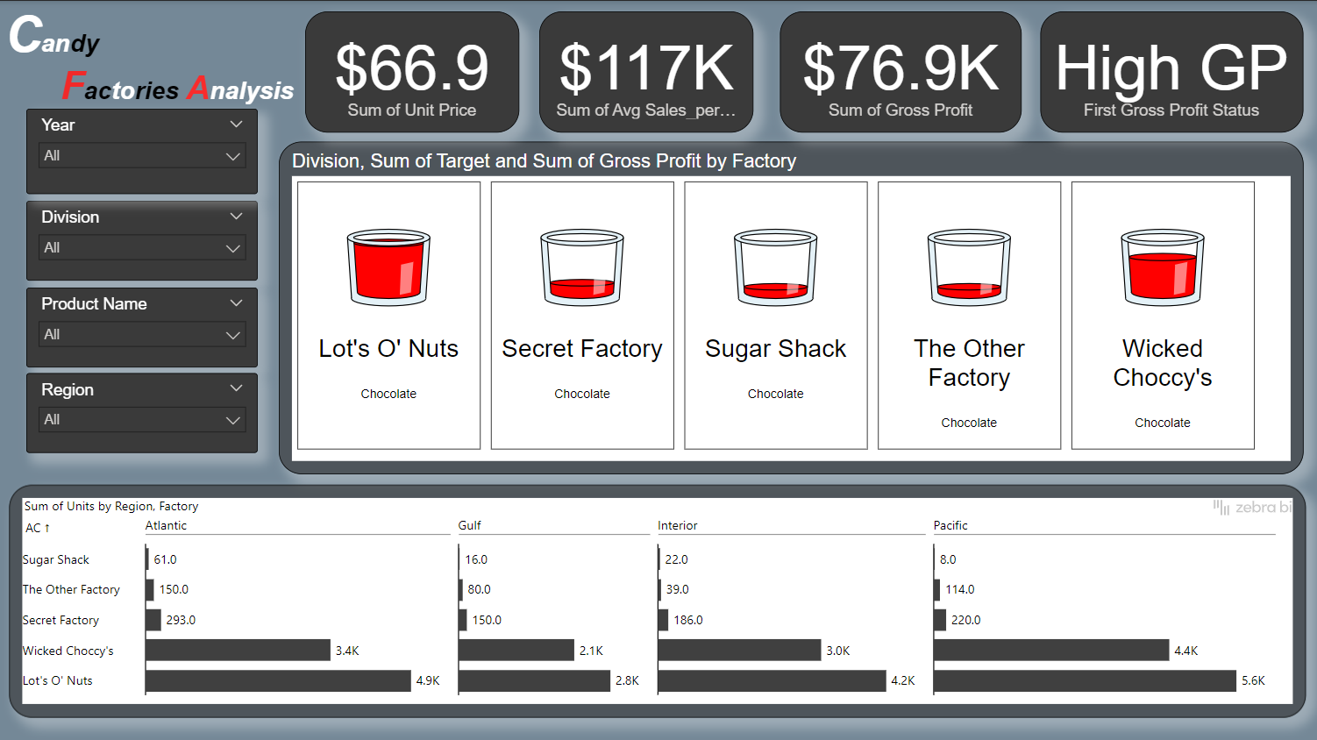

### **Key Metrics (Top Panel)**

1. **Sum of Unit Price**: Displays the total unit price across all products, giving a sense of the overall pricing.
2. **Sum of Avg Sales per Unit**: Shows the total of average sales per unit, which may indicate the revenue generated per unit sold.
3. **Gross Profit**: Displays the total gross profit across all products, indicating the profitability of candy production.
4. **Gross Profit Status**: This indicates that the dashboard is to show items with a high gross profit status or mid or low

**Filters (Left Panel)**

* **Year, Division, Product Name, and Region** filters allow users to narrow down the data displayed based on specific criteria. Selecting different options will adjust all the visuals on the dashboard according to the chosen values.

**Factory Performance (Middle Panel)**

* The middle section provides a visual overview of each factory:
  + **Lot's O' Nuts, Secret Factory, Sugar Shack, The Other Factory, and Wicked Choccy's** are the factories being analysed.
  + Each factory has a cup graphic, which likely represents the percentage of sales or gross profit achieved relative to a target. The red fill level indicates performance—higher red fill suggests better performance in terms of target achievement.

**Sum of Units by Region and Factory (Bottom Panel)**

* This segmented bar chart breaks down the **Sum of Units** by **Region** (Atlantic, Gulf, Interior, Pacific) and **Factory**. It shows:
  + Unit sales for each factory across different regions, helping to identify the top-performing factories in each geographic area.
  + For example, "Wicked Choccy's" and "Lot's O' Nuts" have higher unit sales in the Pacific region, while "Secret Factory" has significant sales in the Atlantic region.

**Summary**

This dashboard helps track each factory's performance by gross profit, unit price, and sales per unit across different regions. It highlights which factories are performing best in each region and whether they are meeting their sales or gross profit targets, providing a comprehensive view of the candy company’s factory output and profitability.

## Report 3: candy shipment analysis

### **1. Title and Theme**:

* The report is titled "Candy Shipment Analysis," indicating it's focused on analyzing candy shipments.
* The color theme is dark with vibrant colors highlighting key metrics and sections.

**2. Filters:**

* There are filters on the left side for **Year**, **Division**, and **Ship Mode**.
* These allow users to select specific years, divisions, or shipment modes to refine the data displayed.

**3. Key Metrics:**

* **Sum of Ship_mode_gp:** Representing the total gross profit or some aggregate value related to shipping modes across all divisions and years.
* **Sumx Sales:** The total sales across all divisions and years.

**4. Bar and Line Chart (Top Right):**

* This chart visualizes **Sum of Sales** and **Sum of Ship_mode_gp** by **Ship Mode**.
* There are four shipment modes: **Standard Class**, **Second Class**, **First Class**, and **Same Day**.
* The **blue bars** represent sales by ship mode, with **Standard Class** having the highest sales, followed by **Second Class**, **First Class**, and **Same Day**.
* The **yellow line** represents **Ship_mode_gp**, which also follows a decreasing trend as the shipping speed increases, suggesting higher shipping costs or lower margins for faster modes.

**5. Average Order per Customer by Ship Mode and Factory (Bottom Right):**

* This section shows the **Sum of Average_order_per_customer** segmented by **Ship Mode** and **Factory**.
* Each factory (e.g., "Sugar Shack," "The Other Factory," etc.) has data segmented by the four shipping modes, showing the average order amount per customer..

**Overall Analysis:**

* **Standard Class** appears to be the most profitable in terms of both sales and average order per customer, suggesting it might be the preferred shipping mode for balancing cost and revenue.
* **Same Day Shipping** is the least profitable, possibly due to higher costs associated with fast shipping.
* The data per factory helps identify which factories perform best under each shipping mode, supporting decisions on optimizing factory-ship mode pairs.